ESS QTP Coding Standard - PopVerify Function

Document Control
Process | Name | Title | Date
Authored by | Webber Ling | Team Lead, Quality Assurance | Jun 22, 2011
Approved by

Revision History
Date | Version | Description | Author
June 22, 2011 | 1.0 | Initial version | Webber Ling

ESS QTP Coding Standard – PopVerify Function
Table of Contents

1. INTRODUCTION - 2 -
1.1 ESS QTP CODING STANDARD – POPVERIFY FUNCITON - 2 -
2. REFERENCE - 3 -
3. PURPOSE - 3 -
3.1 PURPOSE of ESS QTP CODING STANDARD – POPVERIFY FUNCTION - 3 -
4. POPVERIFY FUNCTION DEFINITION AND WORKFLOW - 3 -
4.1 DESCRIPTION - 3 -
4.2 POPVERIFY FUNCTION FOLDER DIRECTORY AND WORKFLOW - 3 -
4.3 POPVERIFY FUNCTION DEFINITION - 4 -
4.3.1 POPVERIFY FUCNTION FOR .NET AUT - 4 -
4.3.2 POPVERIFY FUCNTION FOR WEB AUT - 8 -
4.4 POPVERIFY FUNCTION PARAMETER - 11 -
4.5 POPVERIFY FUNCTION NAMING CONVENTION - 12 -

ESS QTP Coding Standard – PopVerify Function

INTRODUCTION

ESS QTP CODING STANDARD – POPVERIFY FUNCITON
This document focuses on PopVerify function to explain in detail about what it is, where it locates, why need it and how it works.
PopVerify function is NOT a function, it is a TYPE of function. It is integrated into ESS QTP Automation Framework and takes the key role in the framework.
The PopVerify function can apply to any type of AUT (Application Under Test) and it is closely connected to its corresponding function library, for example, for .Net application, its PopVerify function directly calls the method/function defined in LibraryFile_Net.vbs, and Web PopVerify function directly calls the method/function defined in LibraryFile_Web.vbs, etc.
PopVerify function has three parts, one is Pop, which used to populate values in the screen, and another is Verify, which used to verify values in the screen. The last part is “Return”, which used to return object property. With these three parts, PopVerify function can fully meet the QA functional testing requirements.

REFERENCE
<ESS QTP Automation Framework.doc>
<ESS_QTPCodingStandard_ObjectRepositoryManagement.doc>
<ESS_QTPCodingStandard_BestPractice.doc>

PURPOSE

PURPOSE of ESS QTP CODING STANDARD – POPVERIFY FUNCTION
The purpose of this document is to introduce the ESS QTP coding standard – PopVerify function which categorized as below:
- PopVerify Function Definition and Workflow
- PopVerify Function Naming Convention

POPVERIFY FUNCTION DEFINITION AND WORKFLOW

DESCRIPTION
The PopVerify function definition and workflow describes its function definition and the internal function call flow and its related Object Repository as well.

POPVERIFY FUNCTION FOLDER DIRECTORY AND WORKFLOW
PopVerify functions are AUT specific functions which apply to its AUT only, which means they are defined and store in <AUTName>_FunctionLibrary_Main.vbs.
PopVerify functions call the methods/functions defined in its corresponding (.Net or Web, etc) function library and are called in the AUT test scripts. The AUT object repository stores all objects and is used in PopVerify function. Refer to below work flow.
All the PopVerify functions are stored in AUT Main Lib, and those functions/methods defined in Web/Net/StandardWin and objects in Object Repository go through PopVerify function to act on Test Script. Refer to the pink dash lines.
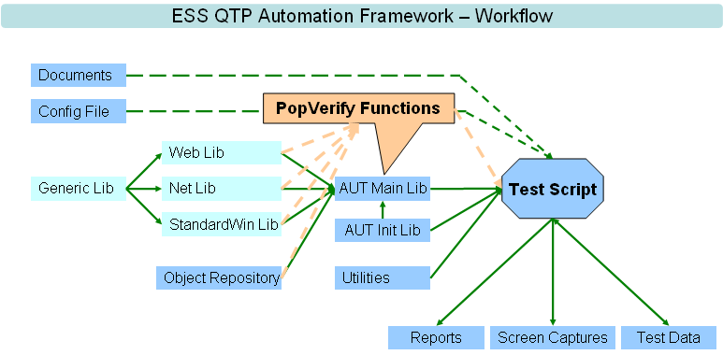

POPVERIFY FUNCTION DEFINITION
PopVerify function is a type of function that defined in AUT main function library. It is a screen-based function which means each screen in the AUT has its corresponding PopVerify function with all objects values as input parameter, which can be used to populate into the screen object or verify, return value from screen object. (In some situations, there maybe lots of objects in one screen, so we can split the PopVerify function for this screen into several PopVerify functions using proper naming convention.)

POPVERIFY FUCNTION FOR .NET AUT
This is an example of .Net AUT (Retirement Studio) PopVerify function.
In .Net application “Retirement Studio”, there is a dialog box named “Client”, refer to below screenshot.

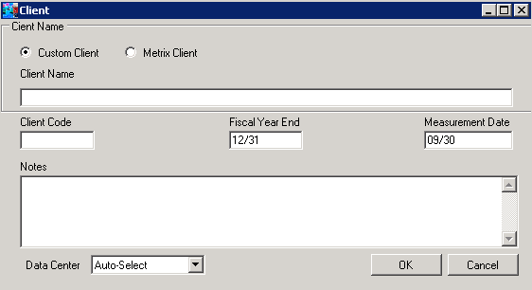
There are ten objects in this dialog, two SwfRadioButton, four SwfEdit, one SwfComboBox and two SwfButton, which means there should be ten objects as input parameter for this PopVerify function. Refer to below screenshot.
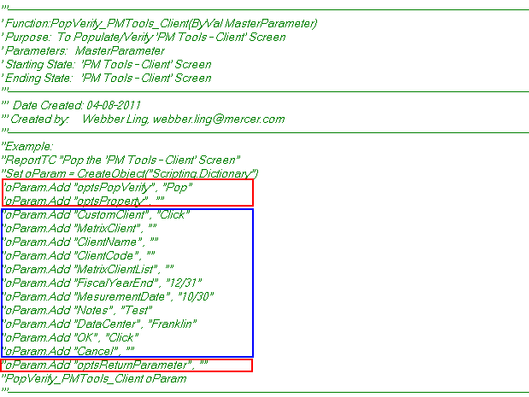
Except above ten parameters which depend on screen objects (in blue rectangle), there are three additional parameters (in red rectangle) which are general parameters for every PopVerify function.
Three General Parameters in PopVerify Function
- optsPopVerify – It indicates which operation the function will carry out, “Pop” to populate the value into screen objects or “Verify” to verify screen object values or “Return” to return the specific object property. Only “Pop”, “Verify” or “Return” is valid input for this parameter.
- optsProperty – This parameter will only be used when parameter optsPopVerify is set to “Verify” or “Return”, this is because the verify/return part will get the screen object runtime property to do the verification or return to user. For example, user want to verify property “text” for a SwfEdit object and then user need to set PopVerify function parameter optsPopVerify to “Verify” and optsProperty to “text”. (Note: optsProperty has its default value for each AUT object type, and in most situations we do not require to set this value just leave it blank. The detailed info will be listed in later chapter.)
- optsReturnParameter – This parameter will only be used when parameter optsPopVerify is set to “Return”, this is because the PopVerify function needs to know which object to return value which based on optsReturnParameter. And optsProperty decides which property to return.
PopVerify Function Code Implementation for .Net AUT
All PopVerify functions’ code implementation follows the same standard and the function has below five parts:
- Parameter Pass – Get the input parameter value using MasterParameter
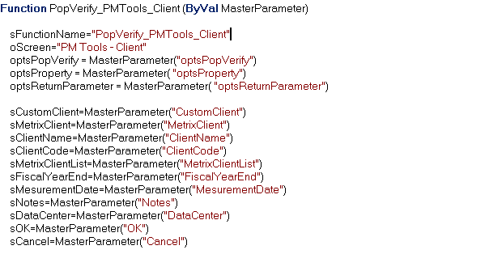
sFunctionName: equals the function name which will be used in step report code to give out user friendly results
oScreen: screen name which will be used in step report code to give out user friendly results
optsPopVerify: indicates which part of codes to go into, “Pop” or “Verify” or “Return”
optsProperty: indicates which runtime property to get from object to Verify or Return
optsReturnParameter: indicates which object to return value
Rest of parameters are screen specific parameters which depend on individual screen, in this scenario, all “Client” dialog box objects are passed into function

- Function Enter Condition Check – Check the expected screen exist and capture screenshot for further reference
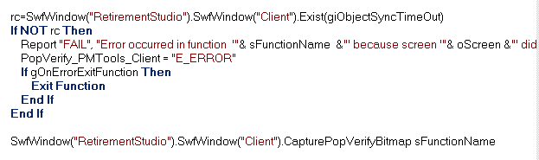
This part is used to do the very basic verification before doing any populate, verify and return action. It checks the expected screen exists or not, if exists, function will go ahead to next step, else it will report an error and let user decide to keep testing or stop execution at this point by popup message box with corresponding options. Refer to below screen capture. (This popup message box displays only in “User-Interaction” mode of script execution which can be configured before test run. If it is set to “Silence” mode, function will keep testing without popup the message box.)
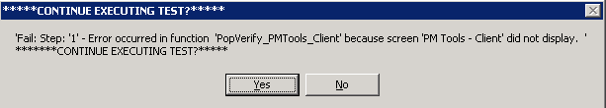
- Populate Code Implementation – Codes for Pop part
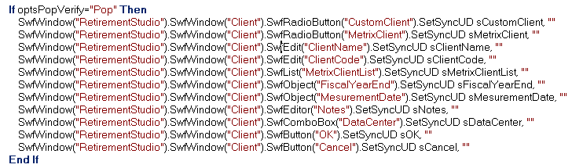
This part is used to do the populate functionality if optsPopVerify is set to “Pop”. All standard .Net objects use the same customized method SetSyncUD which are defined in LibraryFile_NET.vbs.
The SetSyncUD method is defined to set value to any type of standard .Net objects, e.g. if sClientName = “TestingClientName” for SwfEdit(“ClientName”) and then the method will set string “TestingClientName” to this object, if sDataCenter = “Franklin” for SwfComboBox(“DataCenter”) and then the method will select drop down item “Franklin” in this combo box.
The first parameter for SetSyncUD method is the value to be set into the object, e.g. sOK = “Click”, the code will click on SwfButton(“OK”). The second parameter is object sync time, the method will use user input value, e.g. 10 seconds to wait for the object to display if it does not exist already. And it will use 5 seconds if there is no user input value like above sample codes.
- Verify Code Implementation – Codes for Verify part
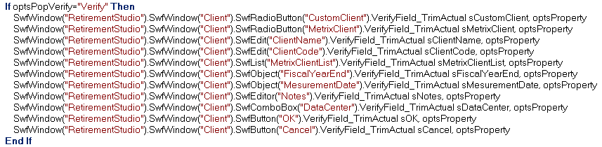
This part is used to do the Verify functionality if optsPopVerify is set to “Verify”. All standard .Net objects use the same customized method VerifyField_TrimActual which is defined in LibraryFile_NET.vbs.
The VerifyField_TrimActual method is defined to verify any type of standard .Net object by comparing the pass-in value and its runtime value. For example, if sDataCenter = “Franklin” and optsProperty = ”” (use its default property “selection”) and then the method will get object current selection to compare with “Franklin” and will report PASS if it matches, FAIL if it does not match.
- Return Code Implementation – Codes for Return part
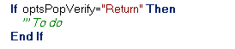
This part is used to return object property when optsPopVerify is set to “Return” and optsReturnParameter points to specific object.
As this part is not frequently used, it is not coded for every PopVerify function like above sample. We keep this condition in the function without any implementation codes for further expanding if required.

POPVERIFY FUCNTION FOR WEB AUT
This is an example of Web application (BA2) PopVerify function.
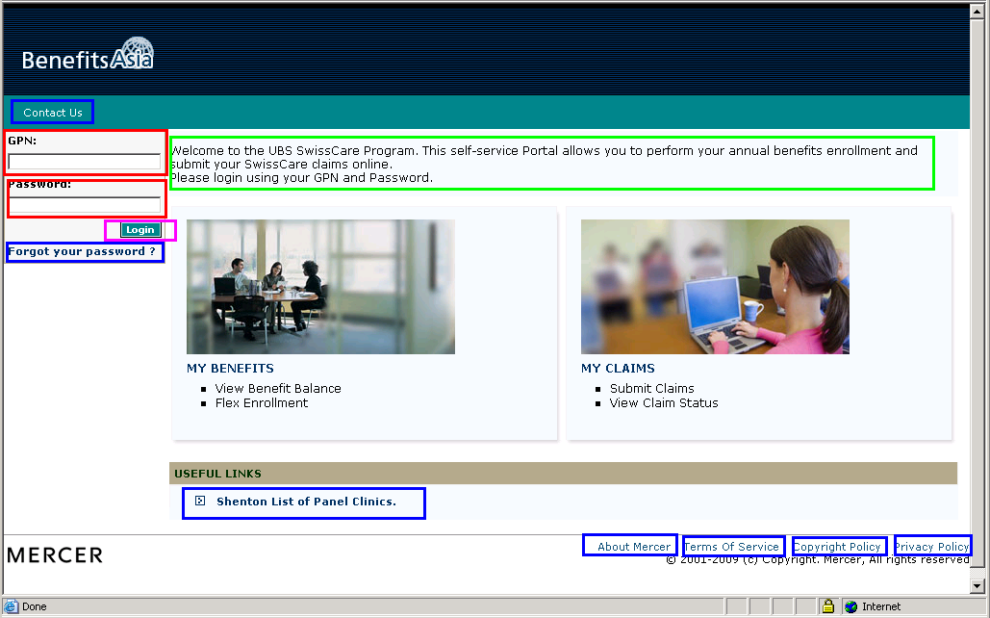
On BA2 login page, it contains many objects which is a very common scenario for a Web page, many WebElements will be identified by QTP as individual object, however many of them are useless for functional testing. (It may be useful if the GUI testing requires.)
Ideally, for PopVerify function, we may cover every object in the screen, but for the functionality testing point of view, cut down the unnecessary objects/codes makes easy maintenance of object repository and function and makes easily function call as well.
In the screen capture of BA2 login page, those important web objects are marked using different color.
WebEdit marked in red rectangle.
Link marked in blue rectangle.
WebButton marked in pink rectangle.
WebElement marked in green rectangle.
With these objects codes implemented in PopVerify function, it is able to meet the functional testing requirements. (And user is able to expand the coverage of this PopVerify function by adding more objects and passing into the function.)

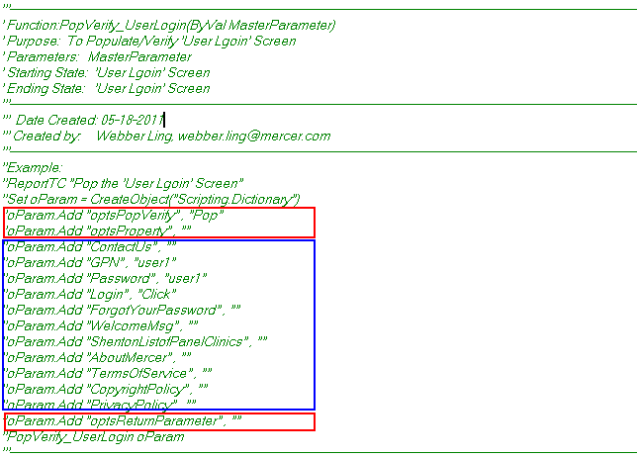
Except above parameters which depend on screen objects (in blue rectangle), there are three additional parameters (in red rectangle) which are general parameters for every PopVerify function, this is generic for all type of AUTs. Refer to .Net PopVerify sample for detailed parameter definition of optsPopVerify, optsProperty and optsReturnParameter.
PopVerify Function Code Implementation for Web AUT
All PopVerify functions’ code implementation follows the same standard and the function has below five parts, it is very similar with the .Net PopVerify function because they follow the same rule.
- Parameter Pass – Get the input parameter value using MasterParameter
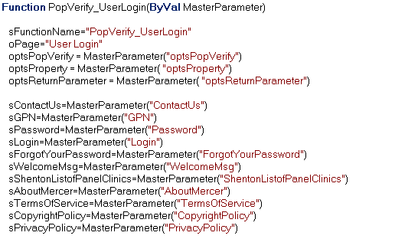
sFunctionName: equals the function name which will be used in step report code to give out user friendly results
oScreen: screen name which will be used in step report code to give out user friendly results
optsPopVerify: indicates which part of codes to go into, “Pop” or “Verify” or “Return”
optsProperty: indicates which runtime property to get from object to Verify or Return
optsReturnParameter: indicates which object to return value
Rest of parameters are screen specific parameters which depend on individual screen, in this scenario, all BA2 “Login” page objects are passed into function
- Function Enter Condition Check – Check the expected screen exist and capture screenshot for further reference
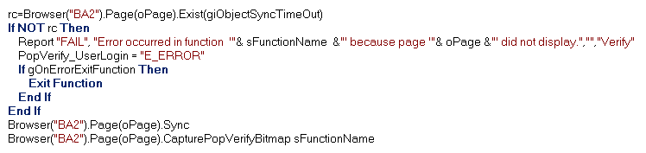
- Populate Code Implementation – Codes for Pop part
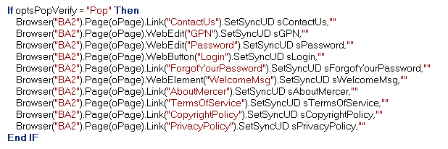
This part is used to do the populate functionality if optsPopVerify is set to “Pop”. All standard Web objects use the same customized method SetSyncUD which are defined in LibraryFile_Web.vbs.
The SetSyncUD method is defined to set value to any type of standard Web objects, e.g. if sPassword = “password01” for WebEdit(“Password”) and then the method will set string “password01” to this object, if sContactUs = “Click” for Link(“ContactUs”) and then the method will click on link “ContactUs”.
The first parameter for SetSyncUD method is the value to be set into the object, e.g. sContactUs = “Click”, the code will click on Link(“ContactUs”). The second parameter is object sync time, the method will use user input value, e.g. 10 seconds to wait for the object to display if it does not exist already. And it will use 5 seconds if there is no user input value like above sample codes.
- Verify Code Implementation – Codes for Verify part
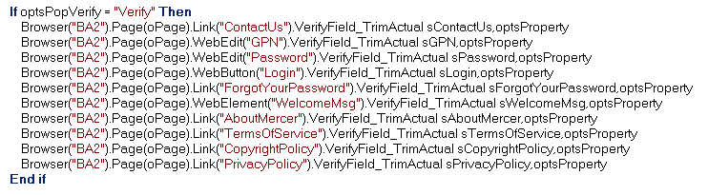
This part is used to do the Verify functionality if optsPopVerify is set to “Verify”. All standard Web objects use the same customized method VerifyField_TrimActual which is defined in LibraryFile_Web.vbs.
The VerifyField_TrimActual method is defined to verify any type of standard Web object by comparing the pass-in value and its runtime value. For example, if sWelcomeMsg = “Welcome to BA2” and optsProperty = ”” (use its default property “text”) and then the method will get object current displayed text to compare with “Welcome to BA2” and will report PASS if it matches, FAIL if it does not match.
- Return Code Implementation – Codes for Return part

This part is used to return object property when optsPopVerify is set to “Return” and optsReturnParameter points to specific object.
As this part is not frequently used, it is not coded for every PopVerify function like above sample. We keep this condition in the function without any implementation codes for further expanding if required.

POPVERIFY FUNCTION PARAMETER
All PopVerify functions use the same format of parameter “MasterParameter”, which is a Scripting.Dictionary object. It supports multiple fields definition and able to use parameter name to index its value. Meanwhile, runtime size expanding is supported to make easy, dynamic maintenance of function parameters.
In below example, from line 3 to line 6, it defines a Scripting.Dictionary object oParam and set value of parameter Param1 as “value1”, “value2” for Param2, “value3” for Param3.
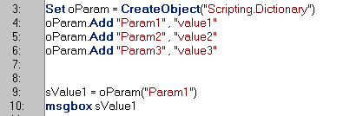
In line 9, assign value of parameter Param1 to variable sValue and use msgbox to display sValue in line10. It shows value1.
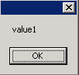
Based on this feature, the PopVerify function uses Scripting.Dictionary as standard input parameter, which is defined outside the function and can be used inside the function.

POPVERIFY FUNCTION NAMING CONVENTION
ESS QTP Automation Framework is a function driven (PopVerify) framework, which means all test scripts are a combination of various screen-based PopVerify functions. It is very important for the function creator to follows standard naming convention. Function caller will frequently look up the function library and pickup expected function based on function name.
Well-defined function name will help function caller to locate function in the library in an efficient way.
For example, for standalone application (Retirement Studio), there is a dialog box whose parent is Retirement Studio Home screen and then we shall name the PopVerify function as “PopVerify_HOME_ServiceProperties”.
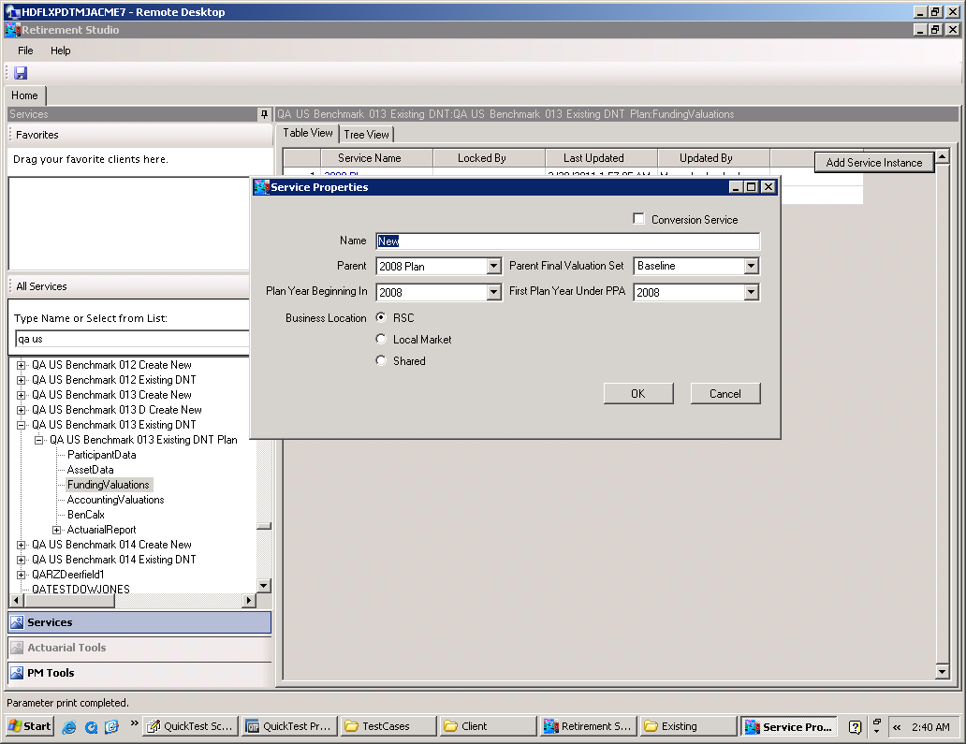
The format of the name of PopVerify function is:
PopVerify_<Parent>_<ScreenName>
- PopVerify: This is the prefix for all PopVerify functions.
- <Parent>: This is the parent screen of the current screen, in this example, “HOME” is its parent screen.
- <ScreenName>: This is the screen which the PopVerify function focus on, it should use the exact the display screen name without space, special characters.

For Web application, it is recommended to use the displayed Page name, e.g. in BA2, there is a login page:
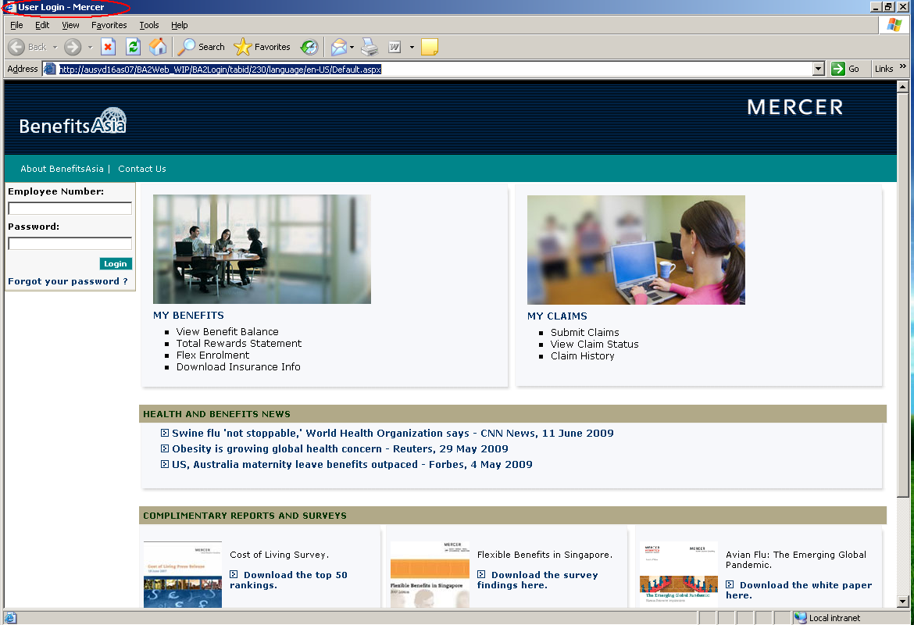
In this case, “PopVerify_UserLogin” is a recommended name for this PopVerify function.

